**Web Programming**

**Btech SEM:V (20-21)**

**Program 3**

**PART-A**

**NAMAN GARG B032 (B2)**

**A.1 Aim:**

Create a static web pages using HTML5

1. Use semantic elements <main>, <header>, <footer>,<section>,<aside>,<article>,<nav>,<figure>,<figcaption>,<details>, <summary>
2. Use media tags <audio>,<video>
3. The forms created in previous practicals need to updated with more HTML 5 tags and attributes (Use

<input> tags type attribute as number, range, datetime-local

attributes: placeholder, autofocus, required

<progress>

1. Use title attribute on any one hyperlink
2. Use strong and em tags on text without using b and i tags.
3. The web page made should be validated at w3c validator <http://validator.w3.org/>
4. Follow html best practices

**A.2 Prerequisite:**

There are no prerequisites as such to learn and implement HTML.

**A.3 Outcome:**

After successful completion of this experiment students will be able to

1. Understand the basic Technique in building a static web application using HTML5
2. Build up well formed html pages

**A.4 Theory:**

**html 5 semantic elements structure**

**<body>**

**<header>**

**<nav> </nav>**

**</header>**

**<main>**

**<section>**

**<article> </article>**

**</section>**

**<aside>**

**</aside>**

**<details>**

**<summary> </summary>**

**</details>**

**<footer>**

**<div> </div>**

**</footer></main></body>**

Syntax of <nav>

<nav>

<a href="html">HTML</a>

<a href="css">CSS</a>

</nav>

Syntax of <figure>

<figure>

<img src="xyz.jpg" alt="xyz">

<figcaption>Fig.1 - xyz.</figcaption>

</figure>

Syntax of <details>

<details>

<summary>Student strength</summary>

<p>This class has 60 students <p>

</details>

**html 5- forms; new tags and attributes**

<input>

<label for="dob">Date of Birth:</label>

<input type="datetime-local" id="dob" name="dob">

<input type="number">

<input type="range">

<progress>

<label for="python">Knowledge in python:</label>

<progress id="python " value="32" max="100"> 32% </progress>

<audio>

<audio controls width=”100” height=”100”>

<source src = "music.mp3" type = "audio/mp3" />

</audio>

**title tag on hyperlink (anchor tag): It displays tootltip text when mouse moves over the link.**

<a href="https://www.google.com" title="This is google's home page">Google.</a>

**HTML Best Practices**

* **"Check" HTML code** with the w3c Validator.  It should pass.
* **Write lang, meta information of your web page as shown below.**
* <!DOCTYPE html>
* <html lang="en">
* <head>
* <meta charset="UTF-8">
* <meta name="author" content="xyz">
* <title>xyz Home page</title>
* </head>
* **Lowercase**.  Use lowercase for elements and attributes  
  Best:  
  <a href="http://xyz.edu">This is a hyperlink</a>  
  Avoid:  
  <A HREF="http://xyz.edu"> This is a hyperlink </A>
* **Quotes**.  Use quotes around attribute values (typically double quotes)  
  Best:  
  <a href="http://xyz.edu/"> This is a hyperlink </a>  
  Avoid:  
  <a href=http://xyz.edu/> This is a hyperlink </a>
* **End tags**.  Use end tags, even if they are optional.  They will help with clarity.  
  Best:
* <ul>
* <li>Tea</li>
* <li>Coffee</li>
* <li>Water</li>

</ul>

Avoid:

<ul>

<li>Tea

<li>Coffee

<li>Water

</ul>

* **Beautify and Prettify.**  Indent nested block-level tags to help with readability.
* **Comment**.  <!-- Comment your code -->   Not excessively, but enough so that the person who reads your code will be able to understand the **what** and **why** -- you might be that person!
* **<p>-.** It’s a good practice to enclose content in <p> tag. Also tags like<br> are not be enclosed directly in <body>. Rather enclose in <p>
* **Avoid** table for layouts
* Use label for form input elements

**Note: It is left to discretion of students to decide the topic to make static webpages on. Also students are given freedom to learn more tags and implement it much better to improve UI of the web page**

**PART B**

**(PART B: TO BE COMPLETED BY STUDENTS)**

**B.1 Software Code written by student:**

<!DOCTYPE html>

<html lang="en">

  <head>

      <style>

        aside {

          width: 30%;

          padding-left: 15px;

          margin-left: 15px;

          float: right;

          background-color: lightgray;

        }

      </style>

  </head>

  <body>

    <header>

      <h2 name = top>MANNA INVESTMENT SERVICES</h2>

    </header>

    <nav style ='text-align: left;'>

      <ul>

        <li><a href="r_from.html" target="_blank">register</a></li>

      </ul>

    </nav>

     <br>

    <main>

    <section>

      <article>

        <h4>

          WIRECARD SCAM

        </h4>

        <figure>

          <div style="width: 20%; height: 20%; border: auto; margin: auto;">

            <a href="http://www.wirecard.com" target="_blank"><img src="wirecard.svg" title="redirects to the wirecard website"/></a>

          </div>

          <figcaption>wirecard</figcaption>

        <figure>

          <p>

            Wirecard AG is an insolvent German payment processor and financial

            services provider at the center of a financial scandal in Germany. The

            company offers its customers electronic payment transaction services and

            risk management, as well as the issuing and processing of physical

            cards. In June 2020, the company's auditor, Ernst & Young found

            discrepancies during their work, which subsequently revealed €1.9

            billion in cash missing.

          </p>

          <aside>

            <em>

            i do not own any wirecard but it is very intersting case study for indian payment services like paytm,instamojo and razorpay

          </em>

        </aside>

        <p>

        CEO Markus Braun resigned and was arrested. On

            June 25, 2020, Wirecard filed for insolvency and Michael Jaffé was

            confirmed as insolvency administrator. In June 2020 a warrant was issued

            for the arrest of Wirecard's former Chief Operating Officer, Jan

            Marsalek. As of July 1, 2020 the company was expected to be dismantled

            by selling off subsidiaries within a few weeks before they lose their

            remaining value and potential buyers expressed interest in buying parts

            of Wirecard.

          </p>

        </article>

        <article>

          <h4>

            Gold: Bet on God's Own Currency

          </h4>

          <figure>

          <div style="width: 20%; height: 20%; border: auto; margin: auto;">

            <a href="https://www.nipponindiamf.com/FundsAndPerformance/Pages/NipponIndia-ETF-Gold-BeES.aspx" target="_blank"><img src="gold2.svg" title="redirects to the nippon/goldman sachs goldbees website"/></a>

          </div>

          <figcaption>gold</figcaption>

        </figure>

        <aside>

          <video width="320" height="240" controls>

            <source src="gold.mp4" type="video/mp4">

            <source src="gold.ogg" type="video/ogg">

            Your browser does not support the video tag.

          </video>

        </aside>

          <p>

            Hedge fund kingpin Ray Dalio is seeing a case for gold as central banks get more aggressive with policies that devalue currencies and are about to cause a “paradigm shift” in investing.

            Dalio, founder of the world’s largest hedge fund, wrote in a LinkedIn post that investors have been pushed into stocks and other assets that have equity-like returns. As a result, too many people are holding these types of securities and likely to face diminishing returns.

            “I think these are unlikely to be good real returning investments and that those that will most likely do best will be those that do well when the value of money is being depreciated and domestic and international conflicts are significant, such as gold,” the Bridgewater Associates leader said.

            “Additionally, for reasons I will explain in the near future, most investors are underweighted in such assets, meaning that if they just wanted to have a better balanced portfolio to reduce risk, they would have more of this sort of asset. For this reason, I believe that it would be both risk-reducing and return-enhancing to consider adding gold to one’s portfolio. I will soon send out an explanation of why I believe that gold is an effective portfolio diversifier.”

            indian households usually like buying physical gold, but that is expensive and eats into your investment returns as there are making charges and gst associated with it, rather you can invest in etfs that track gold price and achive easier selling and storage of gold.

          </p>

          <label for="gold_allocation">gold allocation in my portfolio:</label>

          <progress id="gold_allocation" value="15" max="100" title="15%"> 15% </progress>

        </article>

      </section>

      <footer><br><a href="two.html" alink="red" vlink="green" link="black" target="_blank"

        >Track my investment journey.</a>

        <a href="r_from.html" alink="red" vlink="green" link="black" target="_blank"

          >register with us.</a>

        <a href="#top" alink="green" vlink="green" link="black"

          >return to top</a><br>

      </footer>

      <br>

    </main>

  </body>

</html>

<!DOCTYPE html>

<html lang="en">

  <head>

    <meta charset="UTF-8" />

    <meta name="viewport" content="width=device-width, initial-scale=1.0" />

    <title>Register</title>

  </head>

  <body>

    <h4 style="text-align: center; font-family: Arial, Helvetica, sans-serif;">

      <strong>for more investment analysis join us::</strong>

    </h4>

    <form

      style="text-align: center; font-family: Arial, Helvetica, sans-serif;"

    >

      <label for="fname">Name:</label><br />

      <input type="text" id="fname" name="fname" /><br />

      <label for="email"></label> enter email <br />

      <input type="text" id="email" name="email" /><br />

      <label for="fname">Username:</label><br />

      <input type="text" id="fname" name="fname" /><br />

      <label for="lname">Password:</label><br />

      <input type="password" id="lname" name="lname" /><br />

      <input type="radio" id="male" name="gender" value="male" />

      <label for="male">Male</label><br />

      <input type="radio" id="female" name="gender" value="female" />

      <label for="female">Female</label><br />

      <input type="radio" id="other" name="gender" value="other" />

      <label for="other">Other</label><br />

      <label for="story">send me a message:</label><br />

      <textarea id="story" name="story" rows="5" cols="33"> </textarea><br />

      <label for="type">What type Of investor are you?</label>

      <select name="type of investor" id="type">

        <option value="institutional">institutional</option>

        <option value="growth">growth</option>

        <option value="dividend">dividend</option>

      </select>

      <br />

      <input type="checkbox" id="newsletter" value="subscribed" />subscribe to

      my newsletter<br />

      <br />

      <label for="age">enter your birthdate</label><br />

      <input type="datetime-local" id="age" name="age" value="age" />

      <br />

      <input type="submit" alt="submit" />

    </form>

  </body>

</html>

<html>

  <div style="padding: 1%; font-family: sans-serif;">

    <table cellspacing="0">

      <caption>

        OUR TRACK RECORD

      </caption>

      <tr>

        <th>Scrip Name</th>

        <th>Company Name</th>

        <th>Returns</th>

      </tr>

      <tr>

        <td colspan="3">ON Going</td>

      </tr>

      <tr>

        <td>MAITHAN</td>

        <td>MAITHAN ALLOYS</td>

        <td>30%</td>

      </tr>

      <tr>

        <td>AFFLE</td>

        <td>AFFLE INDIA</td>

        <td50%</td>

      </tr>

      <tr>

        <td>BSE</td>

        <td>BOMBAY STOCK EXCHANGE</td>

        <td>25%</td>

      </tr>

      <tr>

        <td colspan="3">MISSED OPPORTUNITIES</td>

      </tr>

      <tr>

        <td>IOLCP</td>

        <td>IOL Chemicals and Pharmaceuticals</td>

        <td>200%</td>

      </tr>

      <tr>

        <td>HATHWAY</td>

        <td>HATHWAY INTERNET SERVICES</td>

        <td>100%</td>

      </tr>

    </table>

    <h5>my investment strategy</h5>

    <ul>

      <li type="square">diversify</li>

      <li type="circle">hedge using gold</li>

      <li>dont time the market</li>

      <li>invest in high growth potential companies</li>

      <a href="index.html">go back</a>

  </div>

</html>

**B.2 Input and Output**

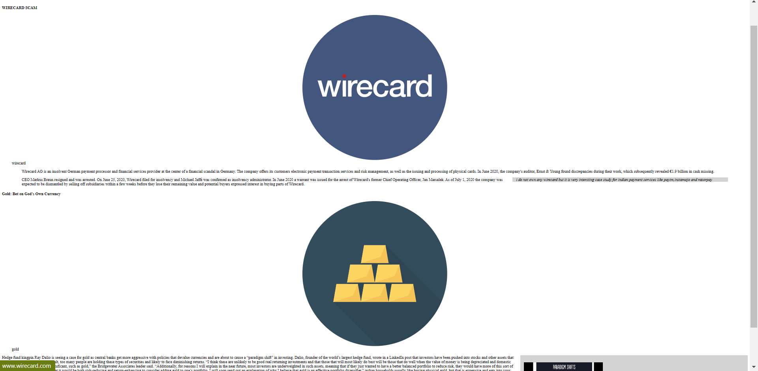

**B.3. Observations and Learning**

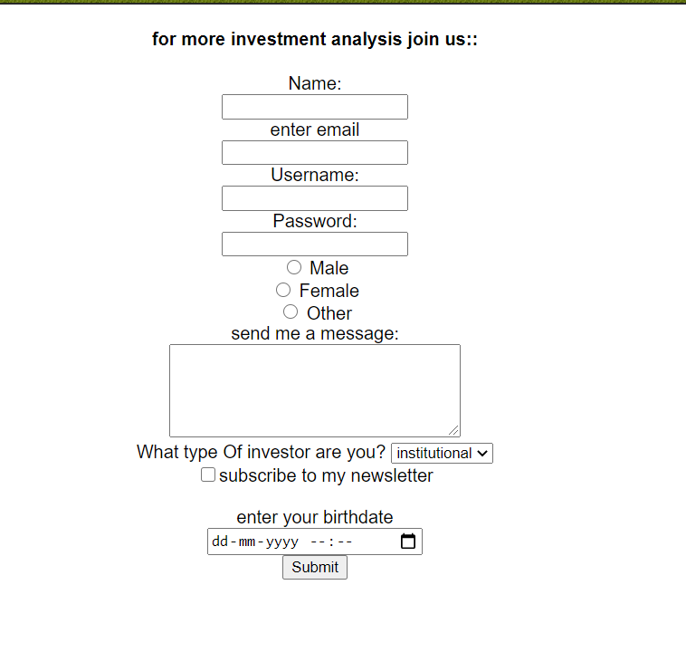 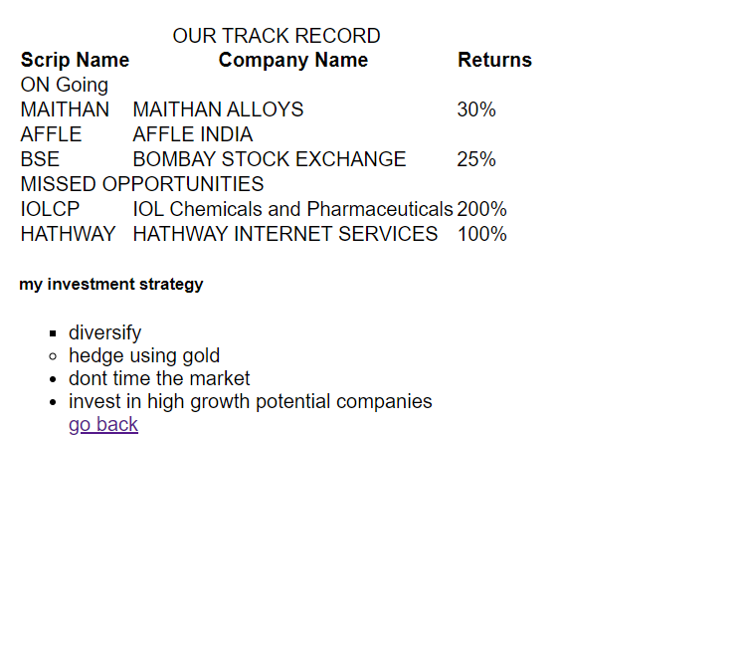

**B.4. Conclusion**

1. Understood the basic Technique in building a static web application using HTML5
2. Built-up well-formed html pages